**Dior Addict**  

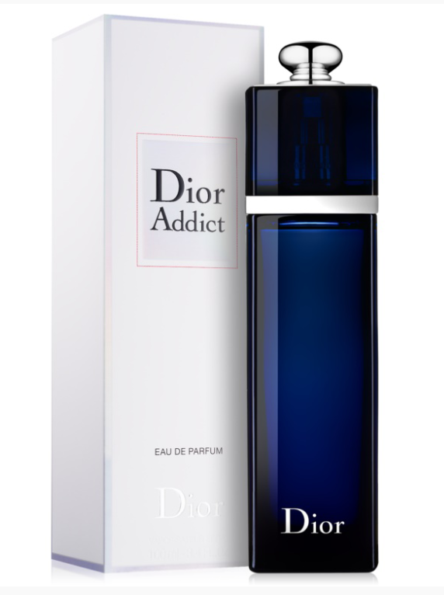

**Dior Addict** by **Dior** is a Amber Floral fragrance for women. **Dior Addict** was launched in 2002. Dior Addict was created by Thierry Wasser and Christian Dussoulier. Top notes are Blackberry, Mandarin Leaf and Silk Tree blossom; middle notes are Jasmine, Night blooming Cereus, Orange Blossom and Rose; base notes are Vanilla, Tonka Bean and Mysore Sandalwood.

Amber fragrance with floral notes. Rich, sensual, encourages you to bold and straightforward actions, it makes you feel free and energetic. Dance! The top notes are mandarin leaves and mulberry flowers; Night Queen Flower, Bulgarian rose and orange flower are in the heart; the base is created with Bourbon vanilla, sandal wood and Tonka bean. The perfume was created by Thierry Wasser in 2002.